Goal: Document the extra components that do not need to be in the backend that needs revision in order to consolidate the extra components.

Component name: Header 1

Type:

Description:

Screenshot:

**List of old components that are not in use currently-**

These components don't make sense according to the new design.

1. **Athenalogin**

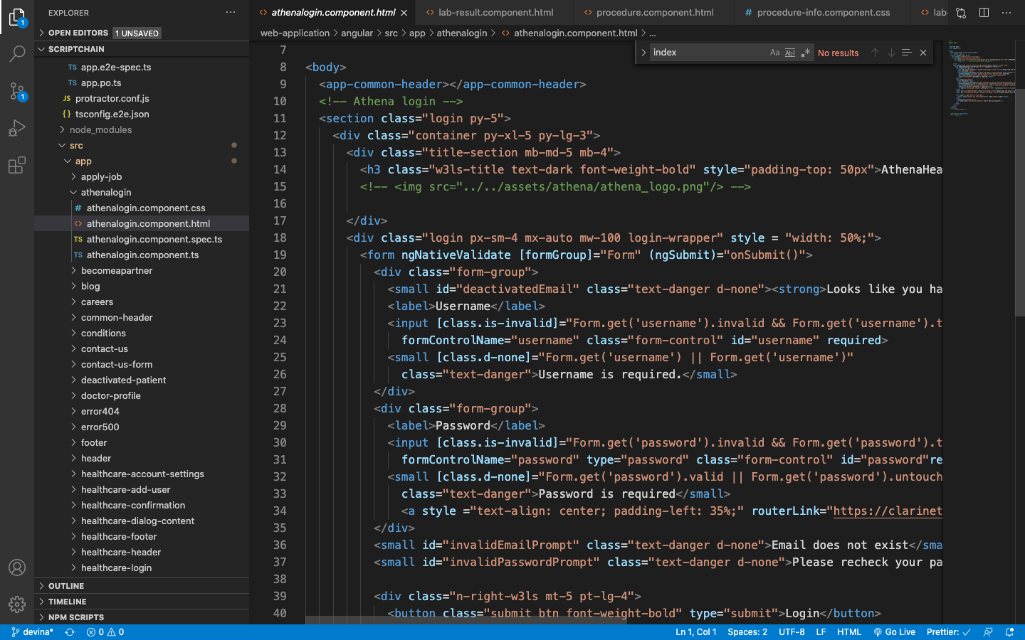

1. Commonheader

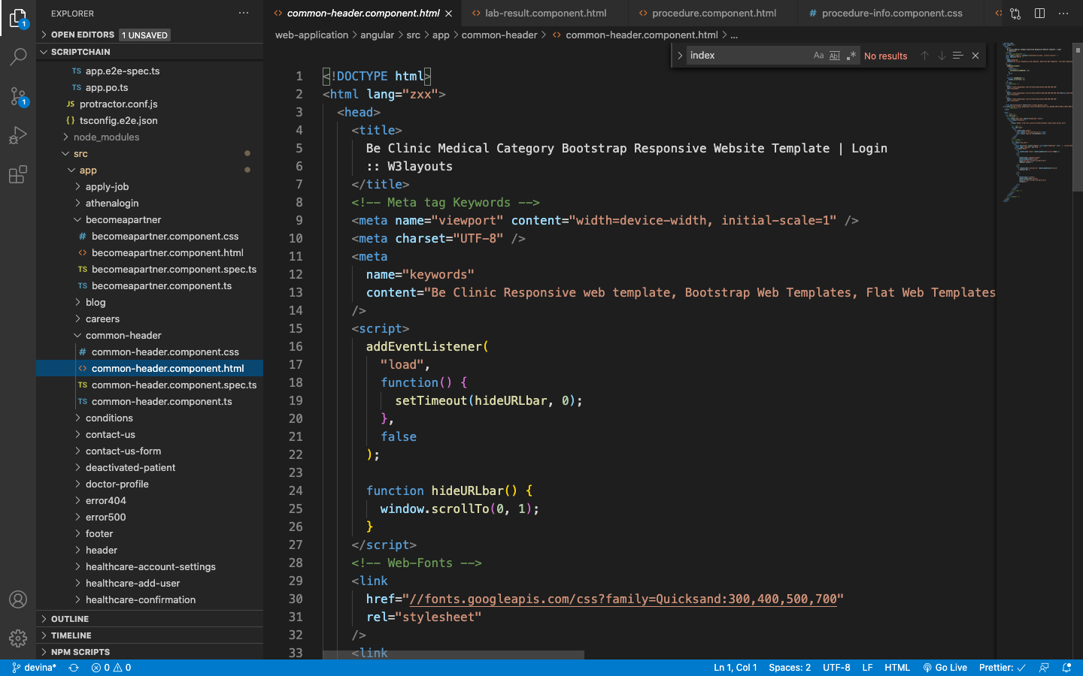

1. Deactivated-patient

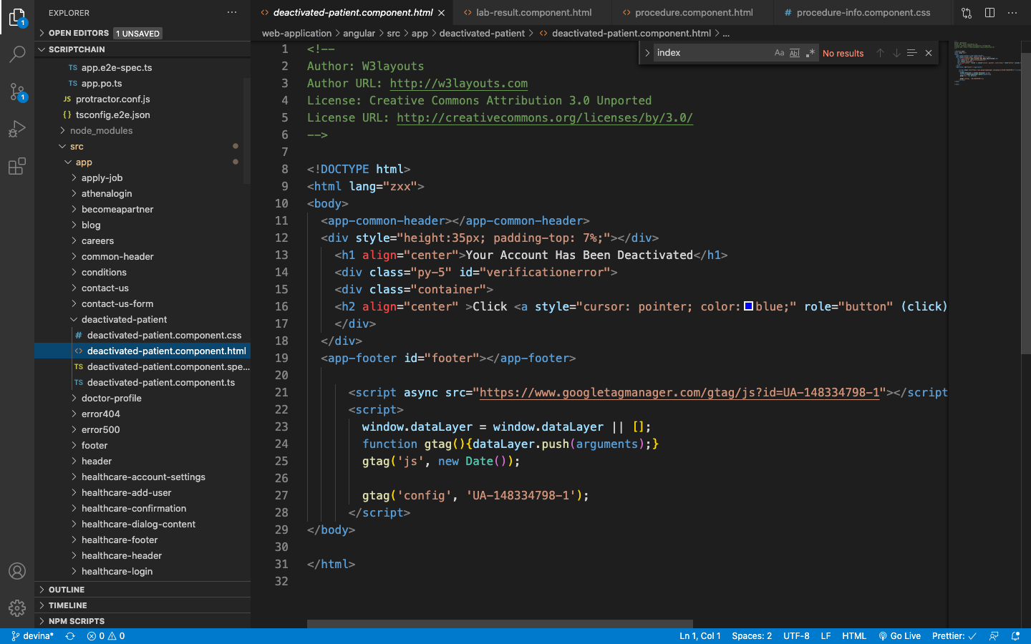

1. Error404

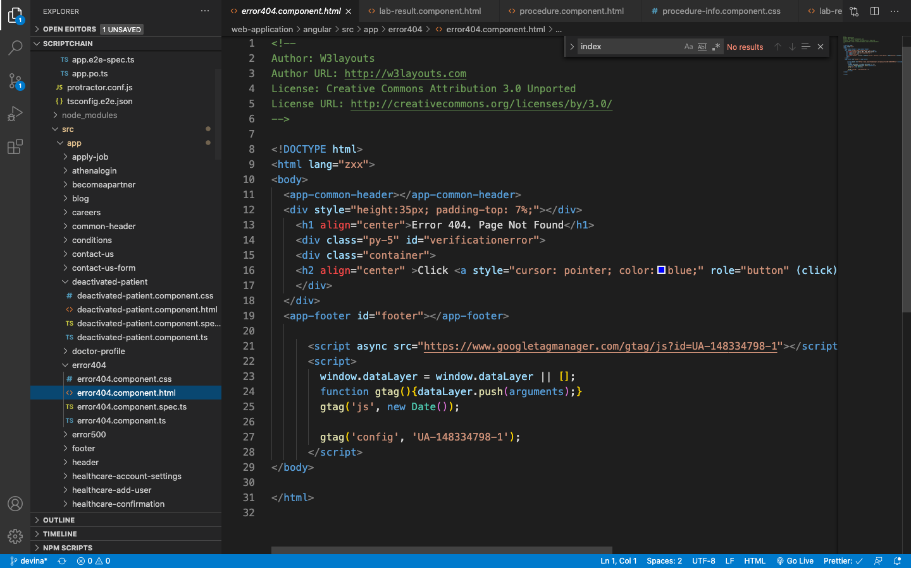

1. Error500

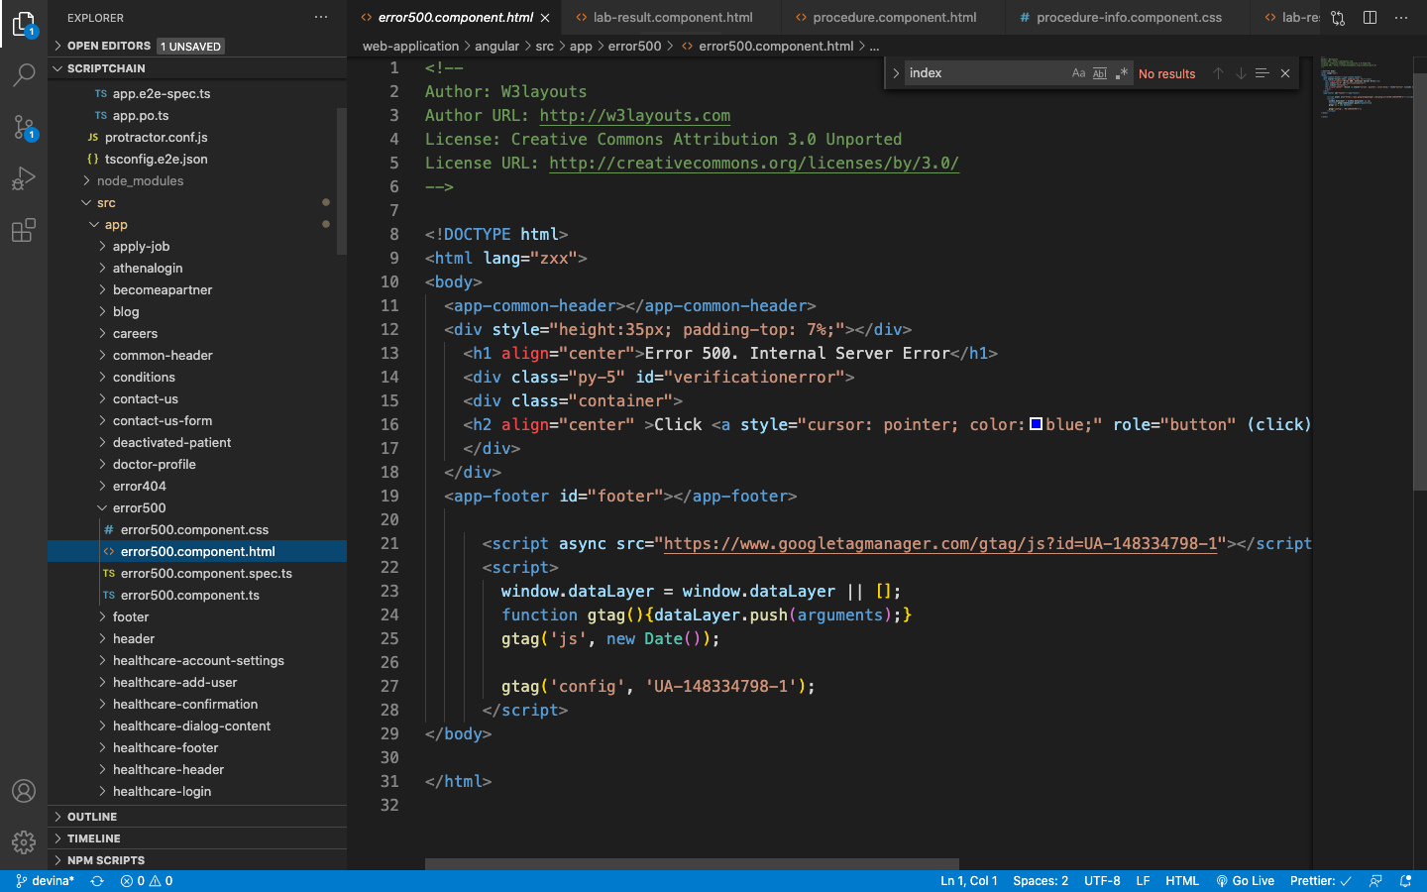

1. Footer

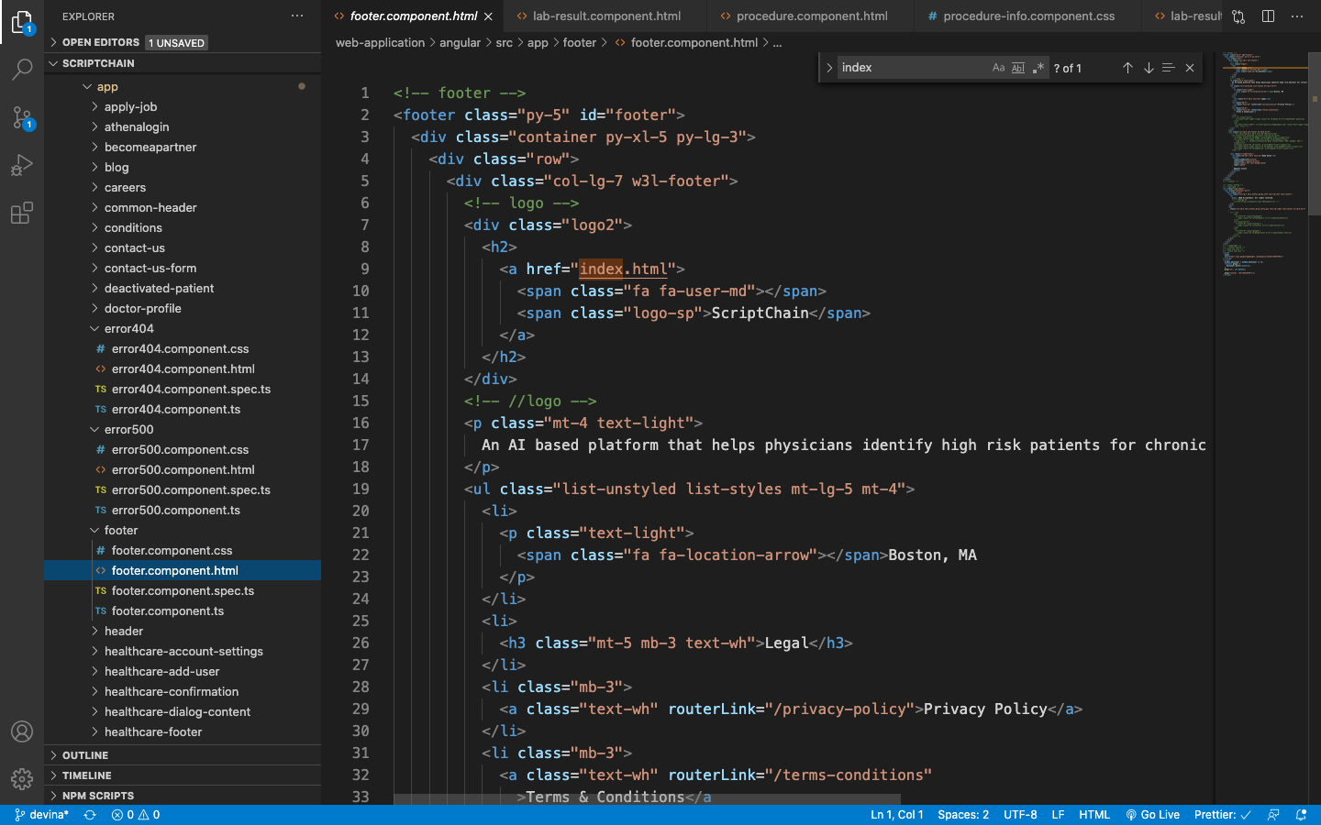

1. Header

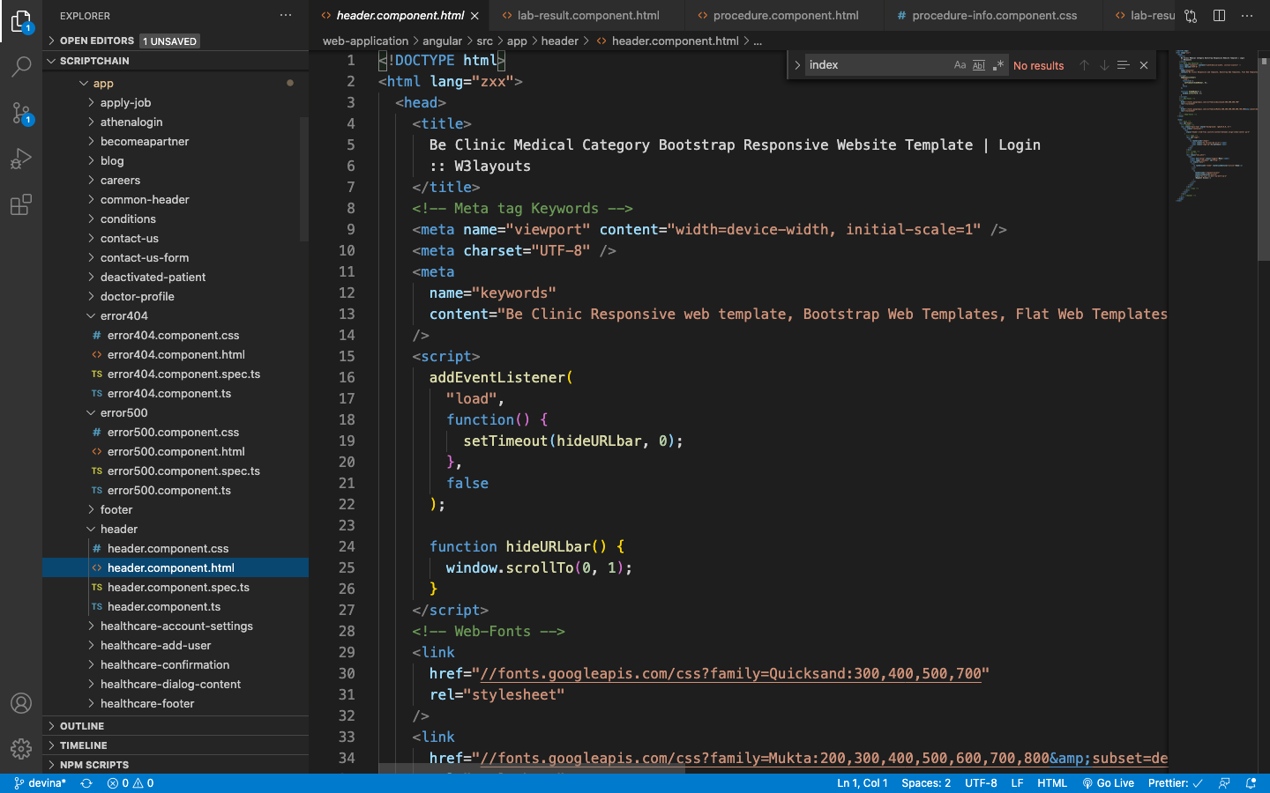

1. Mat-confirm-dialogue

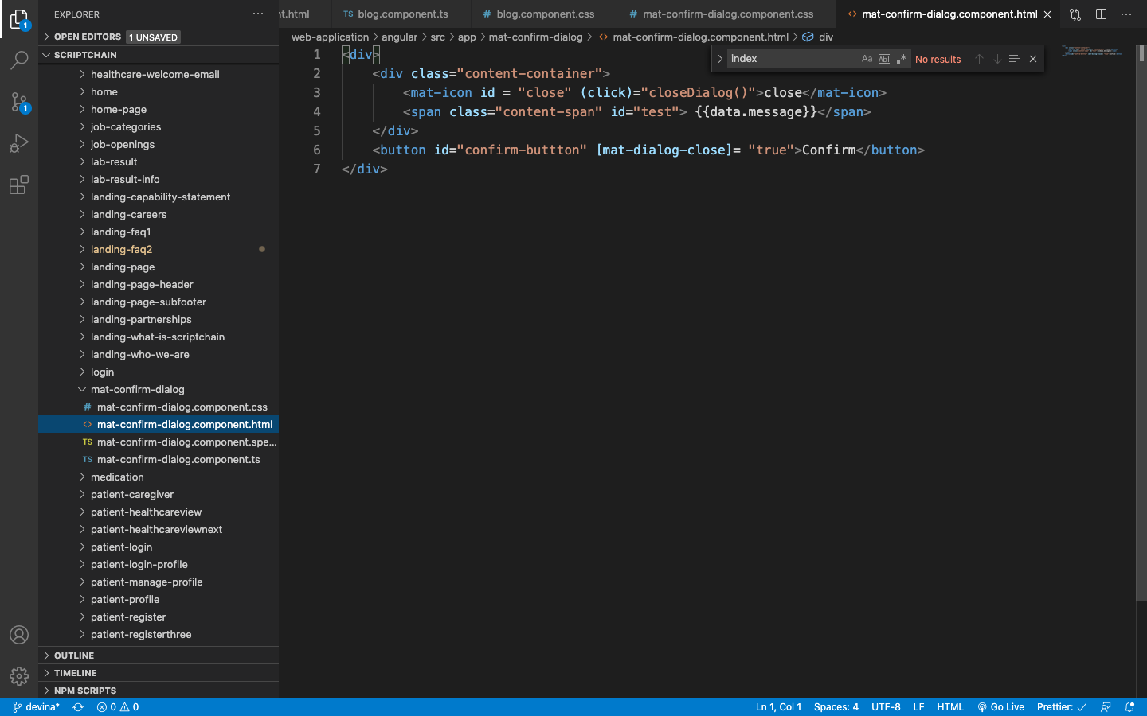

1. Reactivate-healthcare-provider

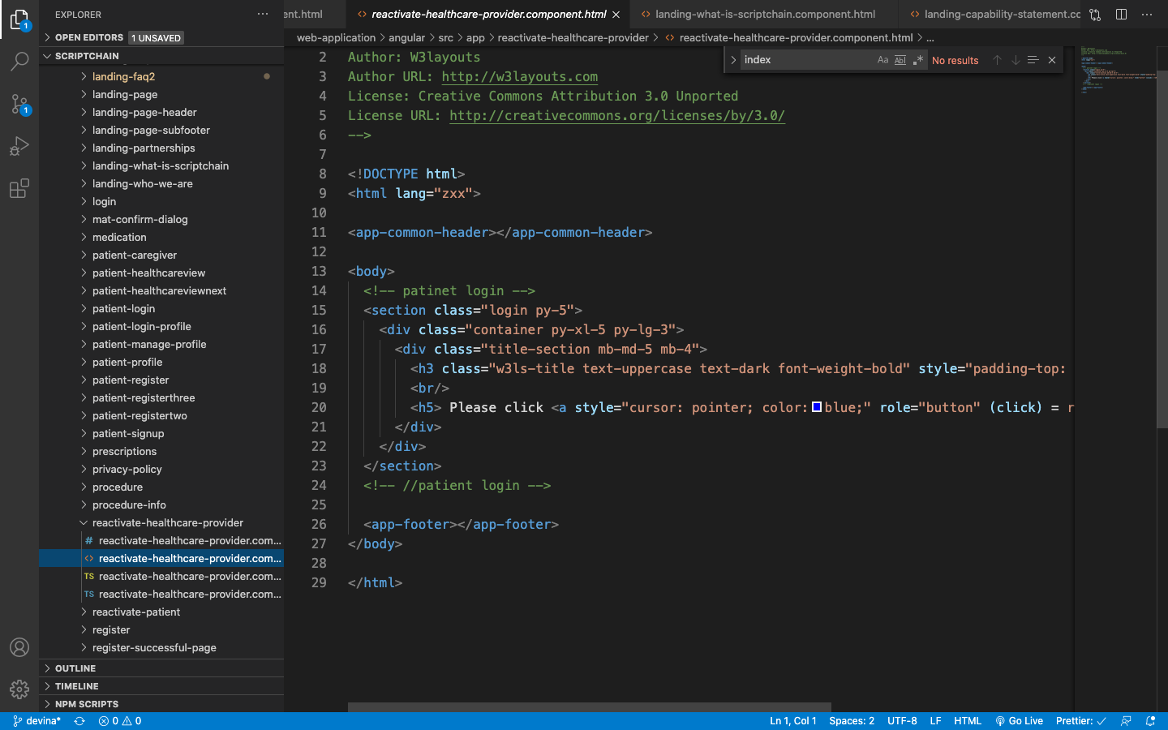

1. Reactivate-patient

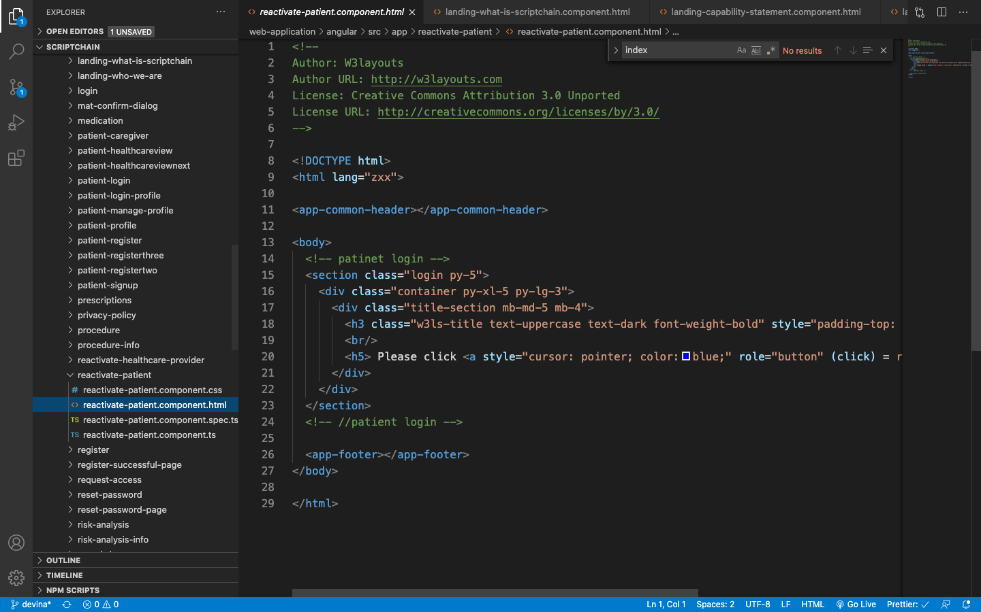

1. Search-bar

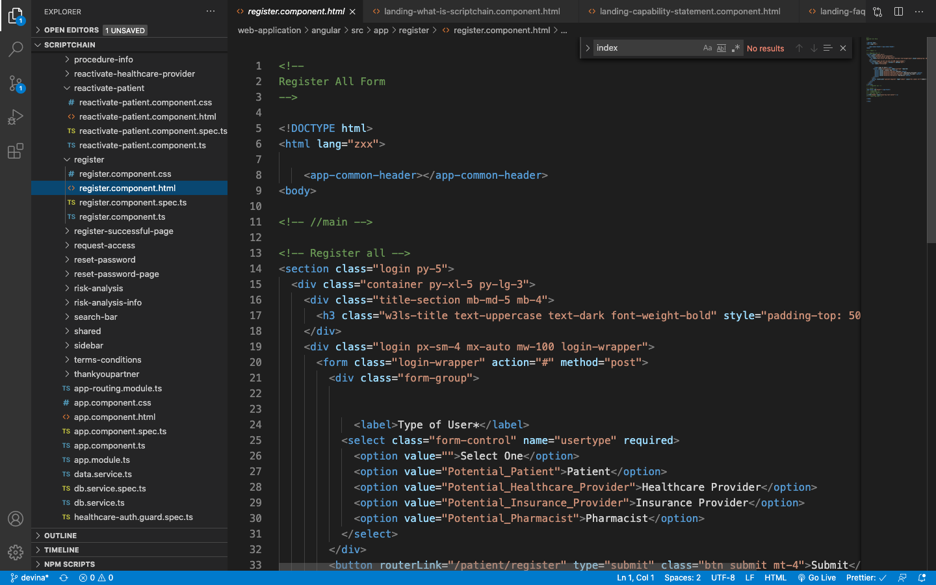

1. Register

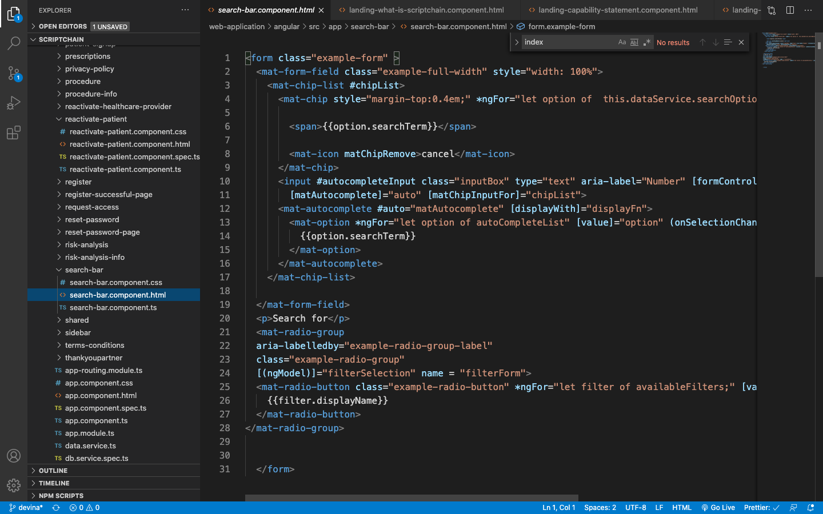

1. Register-successful-page

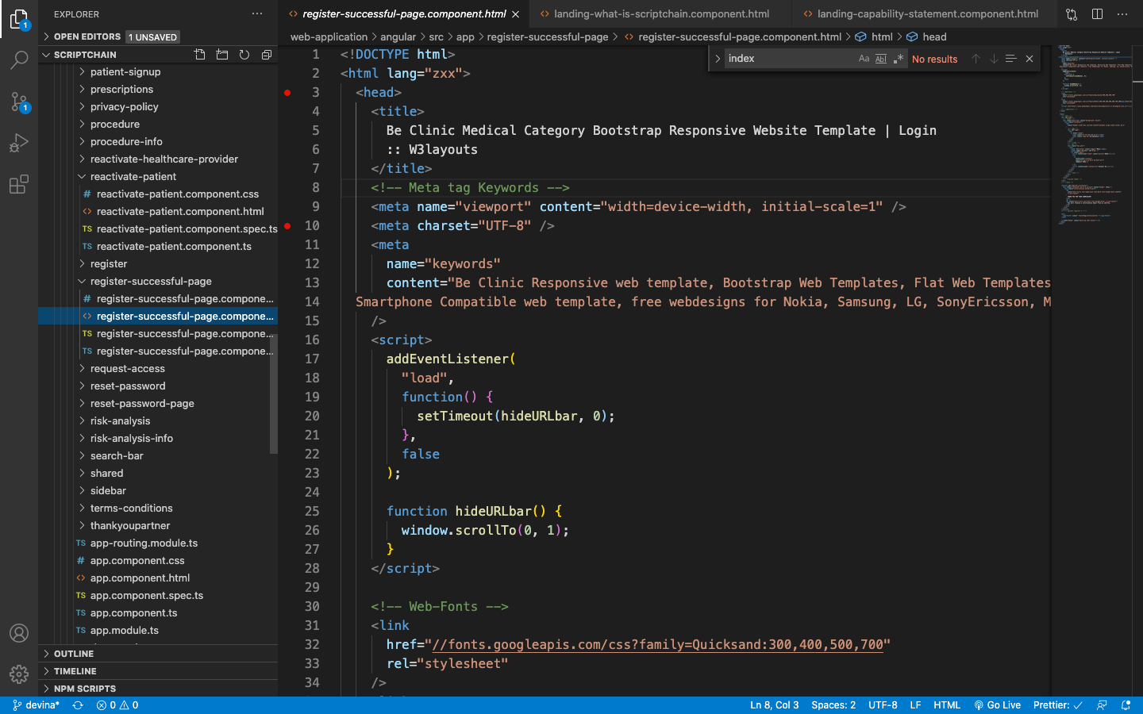

1. Reactivate-patient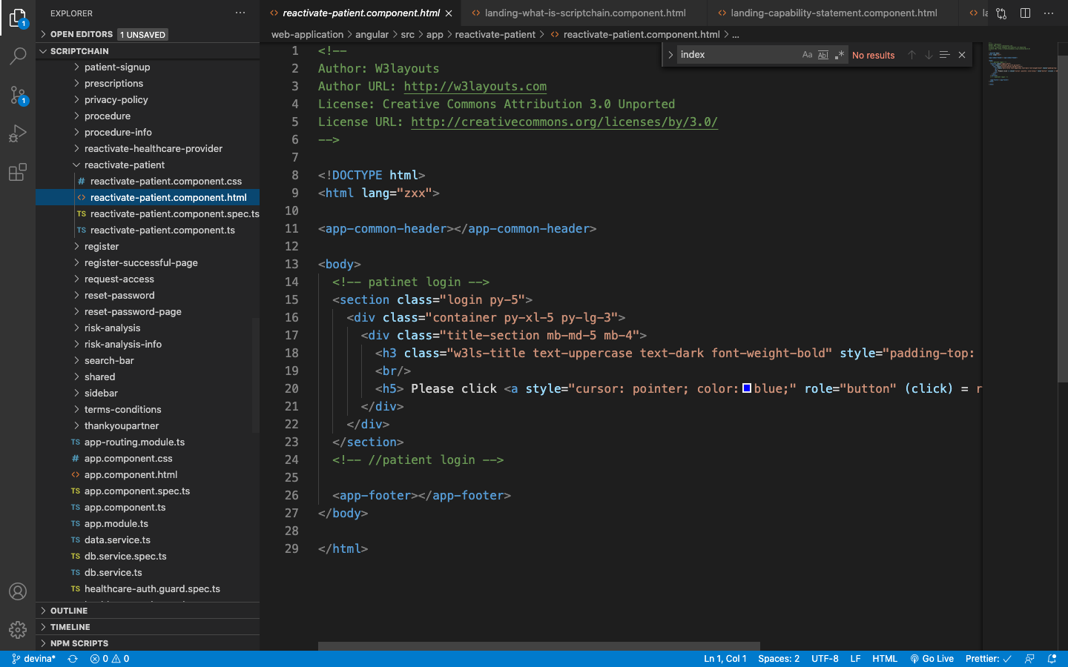
2. sidebar

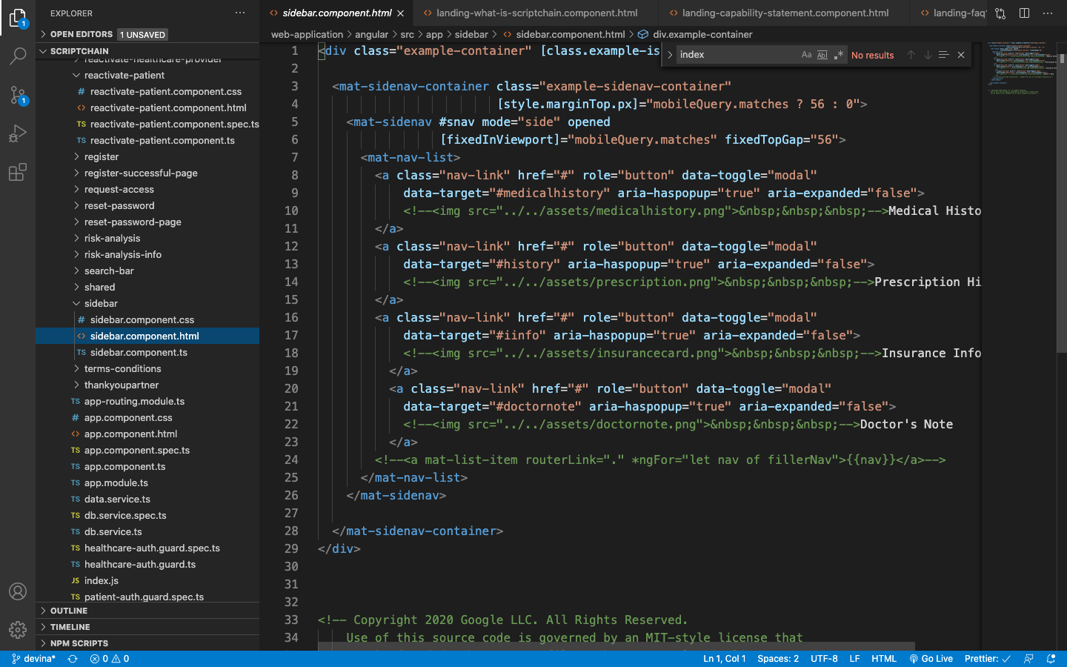

**List of old components that can be used in the future-**

These components have an old user interface but they can be modified according to the new theme and UI.

1. Privacy-policy

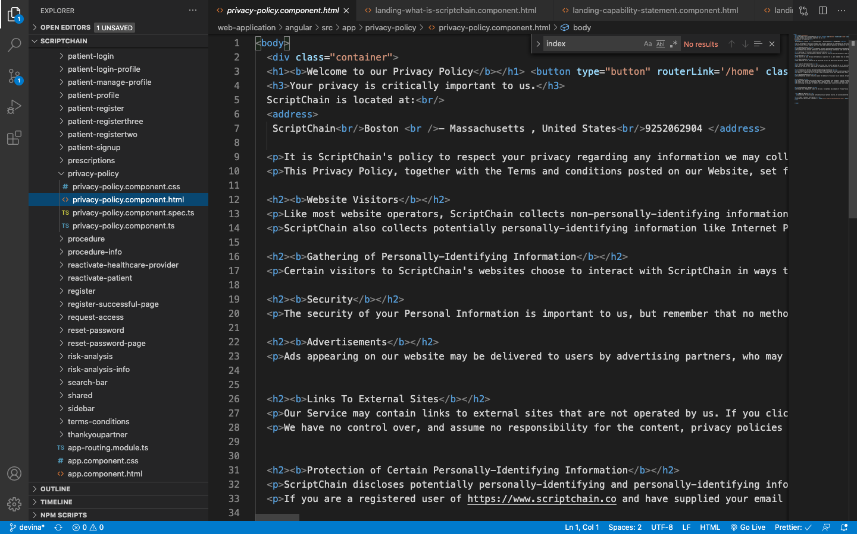

1. Terms-conditions

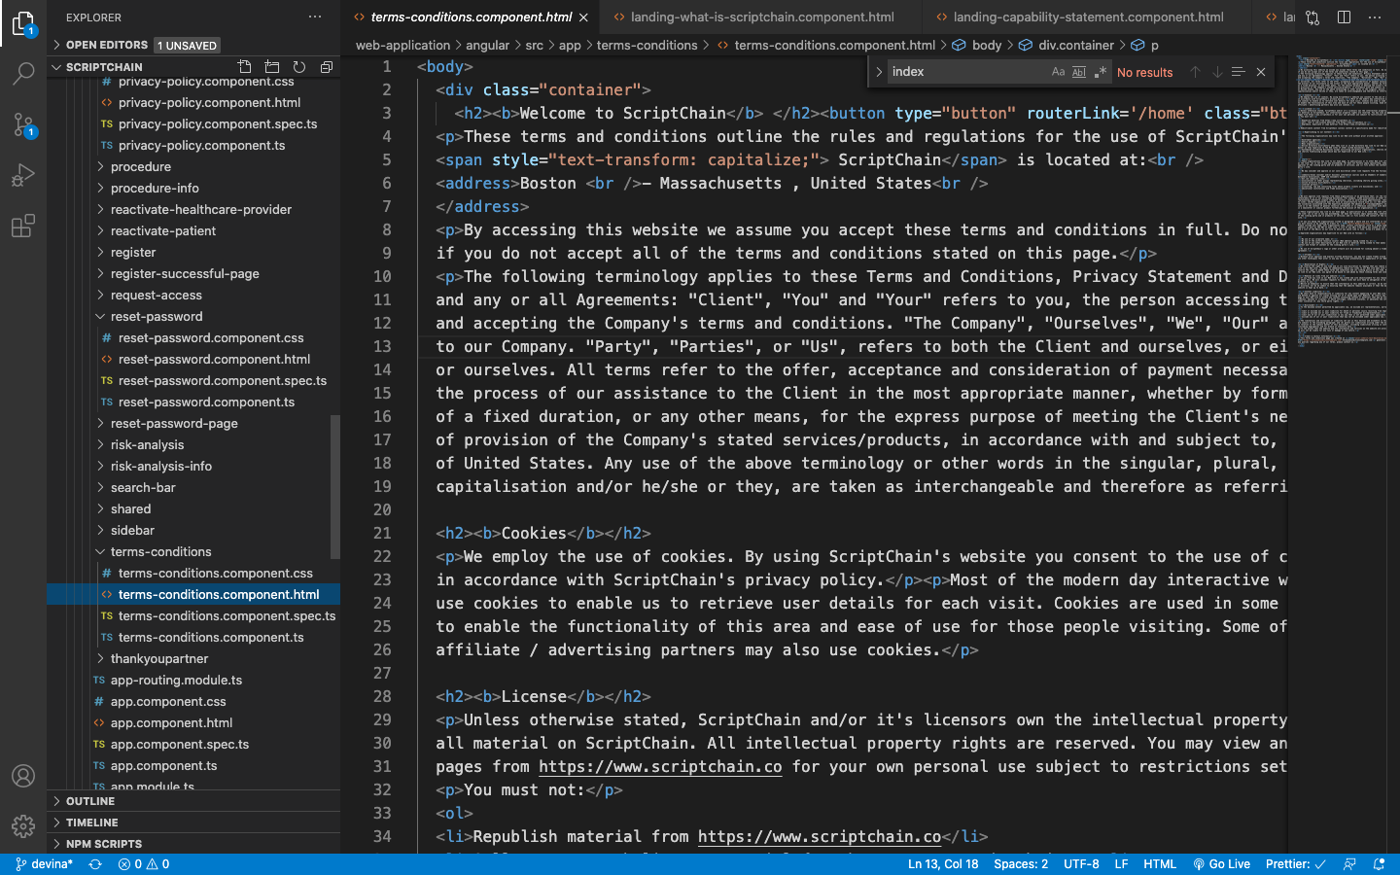

1. Request-access

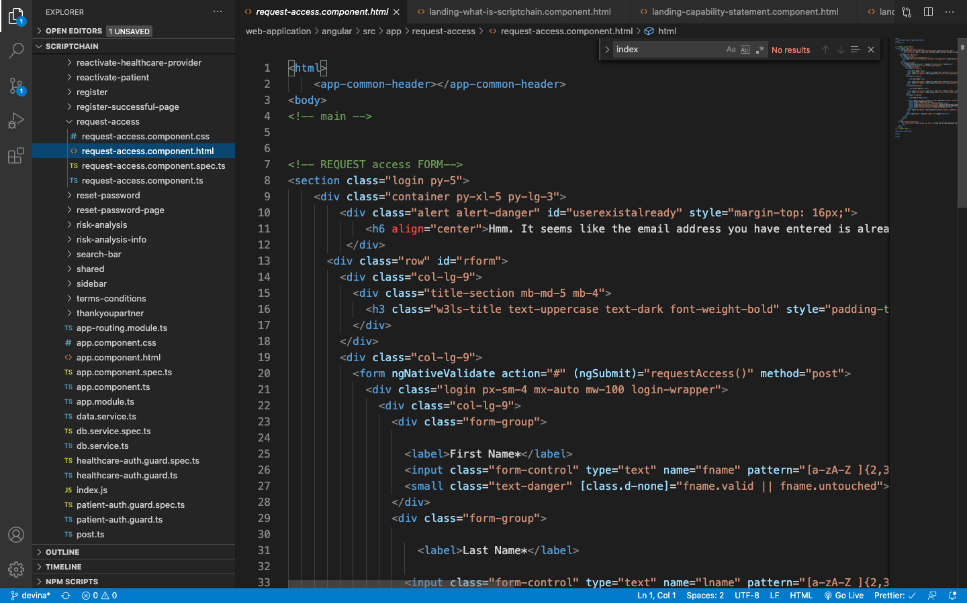

1. Reset-password

